**FAST- National University of Computer & Emerging Sciences, Karachi.**Fast

**Department of Computer Science**

**Quiz - 2, Spring 2023**

| **Course Code: CS3001** | **Course Name: Computer Networks** |
| --- | --- |
| **Instructors: Ms. Yusra Kaleem** | |
| **Student Name:** | **Section & Roll No.:** |

**Time Allowed: 35 minutes Maximum Points: 50**

**Note: Attempt any 5 questions, where question number 2,3 and 5 are COMPULSORY.**

**Question 1**:

Briefly discuss the following: **[10 points]**

**(a)**: Provide three advantages of UDP over TCP.

**(b)**: The DNS requires reliability as one of the important features. However, DNS uses UDP instead of TCP, and UDP does not provide any reliable data transfer implementation, so data can be lost,

(i) so why UDP is used, and (ii) how reliability can be handled.

**(a)**: Provide three advantages of UDP over TCP.

**Ans:**

- no setup/handshaking needed (no RTT incurred)

- can function when network service is compromised

- helps with reliability (checksum)

**(b)**: The DNS requires reliability as one of the important features. However, DNS uses UDP instead of TCP, and UDP does not provide any reliable data transfer implementation, so data can be lost,

(i) so why UDP is used, and

(ii) how reliability can be handled.

**Ans:**

(i) - UDP is used, because every msec count, and we need extremely fast response from UDP (and three-way handshake in TCP is a much overhead for DNS)

(ii) Yes, data can be corrupted (or even lost), so we have checksum and in case of error detection, we simply request again. Anyways, because packet size is very small, normally less than 1KB, chances of error are also low, due to fewer bits in the data packet.

**Question # 2: [10 points]**

Complete the missing sequence numbers (Seq), acknowledgment numbers (ACK), and segment length (LEN) in the following TCP connection. We assume that:

- No timeouts occur at the receiver. The sender starts the timer at t1.

- The connection is full duplex (bi-directional data flow in the same connection).

- The sender and the receiver always have data to transmit.

- There are no delayed acknowledgements at the sender or the receiver.

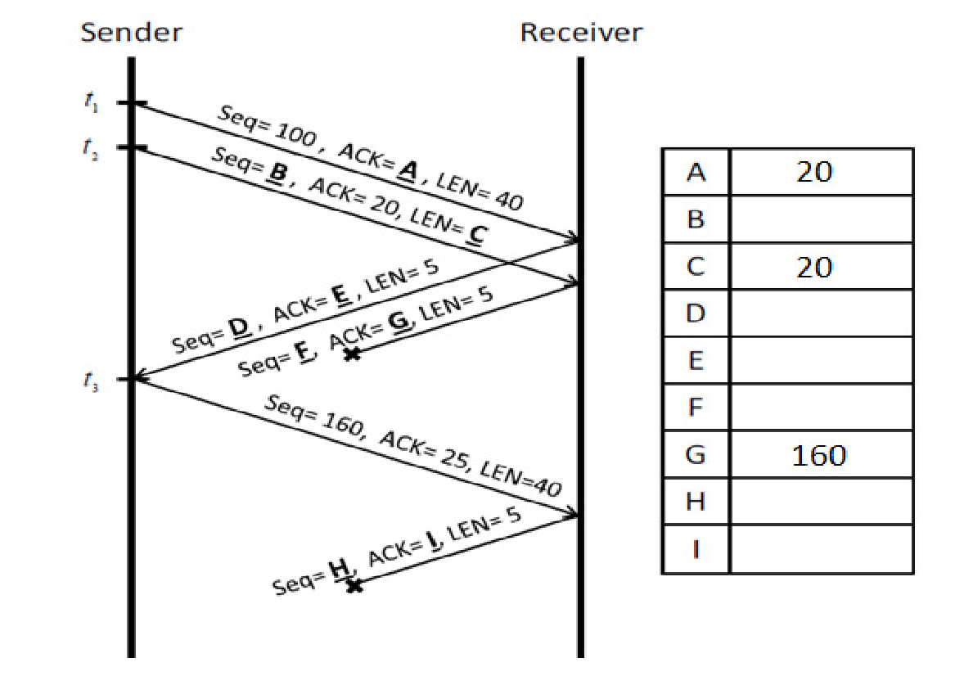

**Solution:**

B = 140; D = 20; E = 140; F = 25; H = 30; I = 200

**Question # 3 [10 points]**

Consider the Figure given below.

**Part a)** Suppose the sender and receiver windows are of size N = 4 and suppose the sequence number space goes from 0 to 9. Show the position of the sender and receiver windows (buffer) over this sequence number space at time **t** (the horizontal line).

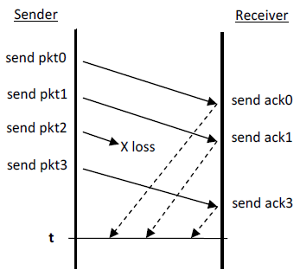

**Part b)** Suppose that it takes 1 ms to send a packet, with a 10 ms one-way propagation delay between the sender and receiver. The sliding windows size is again *N* = 4. What is the channel utilization?

**Solution:**

**Part a)**

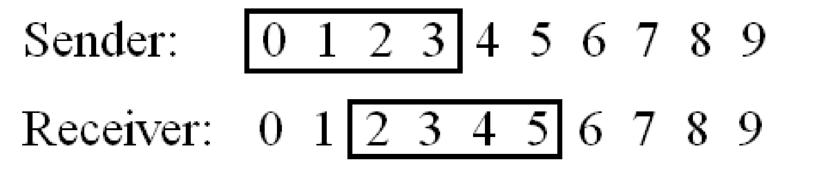

**Part b)** Suppose that it take 1 ms to send a packet, with a 10 ms one-way propagation delay between the sender and receiver. The sliding windows size is again *N* = 4. What is the channel utilization?

Solution:

The utilization is 4/(1+20)= 0.19 or 19%

**Question # 4: [10 points]**

Design a reliable data transfer protocol between the sender and receiver, operating over a channel that can lose or corrupt packets (data or ACKs) and is error prone. Specify the protocol using finite state machine for the sender side.

Solution:

**Question # 5: [10 points]**

A provider has been assigned the network 209.118.127.0/23 and wants to divide it among three customers. Ufone needs to accommodate up to 250 hosts, Zong needs to accommodate up to 48 hosts, and Telenor needs to accommodate up to 120 hosts. Fill the following table in your answer script with the details of the sub-networks that the provider can create to fit its customers' needs.

Solution:

| Subnet No. | Network Address | Custom Subnet Mask | Host Range | No. Of Hosts |
| --- | --- | --- | --- | --- |
| Ufone | 209.118.126.0/ 24 | 255.255.255.0 | 209.118.126.0 ---  209.118.126.255 | 254 |
| Zong | 209.118.127.0/26 | 255.255.255.192 | 209.118.127.0 ---  209.118.127.64 | 48 |
| Telenor | 209.118.127.128/25 | 255.255.255.128 | 209.118.127.128 ---  209.118.127.255 | 126 |

**Question # 6: [10 points]**

a) When a new device joins a network how it gets the IP address automatically? Explain the procedure with diagram.

b) In first two messages of DHCP what is the destination & sources address in IP packet header? Take 192.168.1.1 DHCP server IP. Why messages in DHCP are broadcast?

Solution # 6(a):

The Dynamic Host Configuration Protocol (DHCP) dynamically assigns IP addresses to new device that joined the network and centrally manages host configurations. DHCP uses the client/server model.

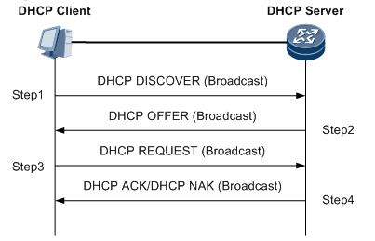

Solution # 6(b):

First Message DHCP Discover:

Source address: 0.0.0.0

Destination address: 255.255.255.255

Second Message DHCP Offer

Source address: 192.168.1.1

Destination address: 255.255.255.255

The broadcast ensures that all the responding DHCP servers know that the client has chosen a server. The servers that are not chosen can cancel the reservations for the IP addresses that they had offered. Also, the new node doesn’t know the address of the DHCP server so it discovers it by broadcasting the message.

**Question # 7: [10 points]**

Consider the two 16-bit words (shown in binary) below. Compute the Internet checksum of a set of 16-bit words.  
01001110   10001111      this binary number is 20111 decimal (base 10)  
00111001   10111001      this binary number is 14777 decimal (base 10)

